**Tutorial 14**

**Backtracking, Greedy method and Dynamic programming**

**Instructions**

1. All tutorial sheets will be posted on the Google Classroom.

2. Students are advised to submit tutorial sheets solutions in classroom.

Q1. A kid likes to play with toys. There are a number of different toys lying in front of him, tagged with their prices. He has only a certain amount to spend and he wants to maximize the number of toys which he can buy with this money. Given a list of prices and an amount to spend, what is the maximum number of toys he can buy?

Input :7 50

1 12 5 111 200 1000 10

Q2. 1. Suppose we want to make change for n cents, using the least number of coins of denominations 1; 10, and 25 cents. Consider the following greedy strategy: suppose the amount left to change is m; take the largest coin that is no more than m; subtract this coin's value from m, and repeat.

Either give a counterexample, to prove that this algorithm can output a non-optimal solution, or prove that this algorithm always outputs an optimal solution.

2. Which strategy can be used that always gives and optimal solution to a problem. Explain the features of this technique.

Q3. What is the minimum number of colours which can be used to colour the following graph.

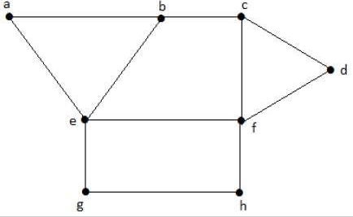

Q4. Solve the following 0/1 knapsack problem using dynamic programming to attain the maximum profit. Consider the problem having weights and profits are:

Weights: {3, 4, 6, 5}

Profits: {2, 3, 1, 4}

The weight of the knapsack is 8 kg

Q5. Find the longest common subsequence using dynamic programming: S1 = {B, C, D, A, A, C, D} and S2 = {A, C, D, B, A, C}